

CMB SEATING ASSESSMENT FORM

Date: Client name:

Contact name: Address:

Contact number:

email:

# Please provide information for any musculoskeletal or spine injuries you may have

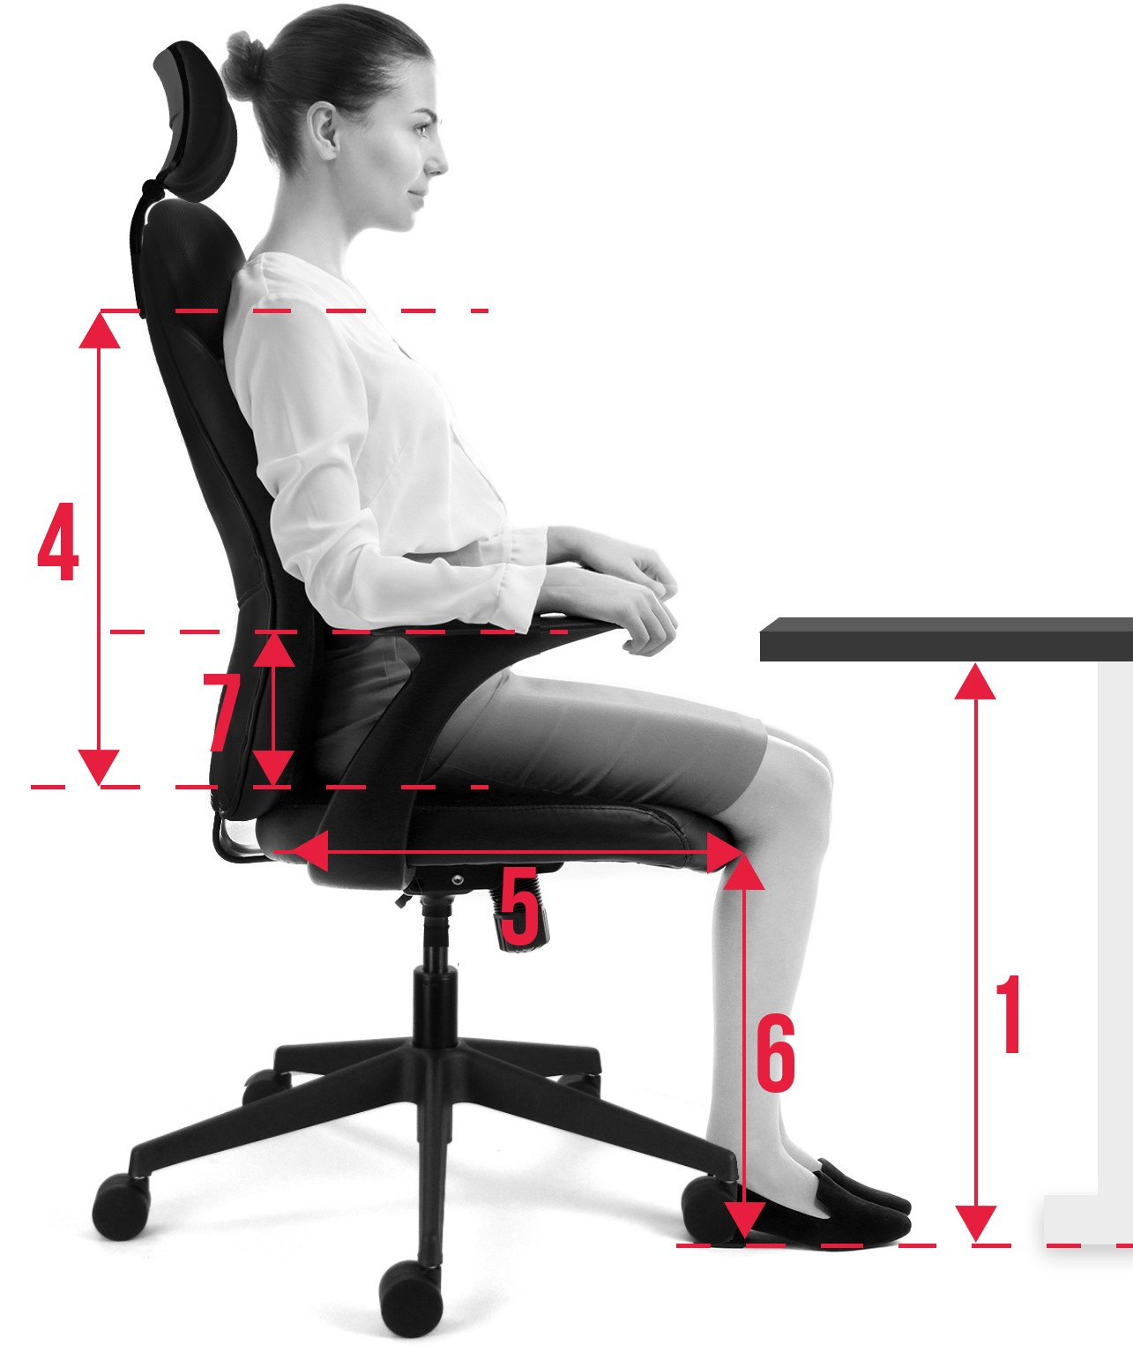Please describe any back pain you experience while seated and what makes that pain better or worse

# Dimensions

Weight (stones/kilos): Height (feet and inches:

|  |
| --- |
|  |
|  |
|  |
|  |
|  |
|  |
|  |

1. Desk height
2. shoulder width
3. Hip breadth
4. seat to shoulder
5. back of buttock to back of knee
6. back of knee to floor
7. Height of lumbar above seat

Do you require arms?

Desk shape, wave, corner, rectangle Floor type

W / C / R

Yes / No

Any other Notes